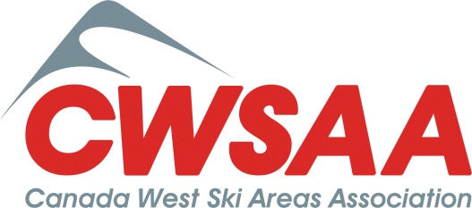

Jim Marshall Leadership Award 2018 Nomination Form

Nomination Form Due to CWSAA, care of Cynthia Thomas (marketing@cwsaa.org), by January 8, 2018.

Nominee Name & Company
Nominee Telephone & Email:
Nominator’s Name & Company
Nominator’s Telephone & Email:

Nomination Justification:

The following outline is provided to describe key qualities, traits, and characteristics of the nominee.

- Describe how the nominee demonstrates leadership and mentorship, give specific examples.

- Describe how the nominee’s personal characteristics demonstrates commitment and passion to their profession, give specific examples.

- Describe how the nominee demonstrates excellence in making a meaningful contribution to the snowsports industry, give specific examples.

Feel free to include additional comments on another page and to include a brief work history of the nominee.

