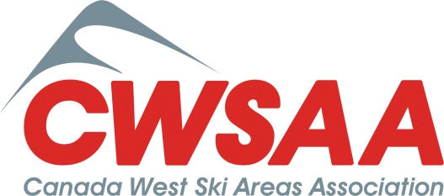

Lars Fossberg Excellence Award 2018 Nomination Form

Nomination Form Due to CWSAA, care of Cynthia Thomas (marketing@cwsaa.org), by January 8, 2018.

Nominee Name & Company:
Nominee Telephone & Email:
Nominator’s Name & Company:
Nominator’s Telephone & Email:

Nomination Justification:

The following outline is provided to describe key qualities, traits, and characteristics of the nominee.

- Describe how the nominee demonstrates ambition & enthusiasm in the work place, give specific examples.

- Describe how the nominee has demonstrates resourcefulness in the work place, give specific examples.

- Describe how the nominee demonstrates dealing with the unexpected & overcoming challenges, give specific examples.

Free feel to add additional comments on another page and to include a brief work history of the nominee.

