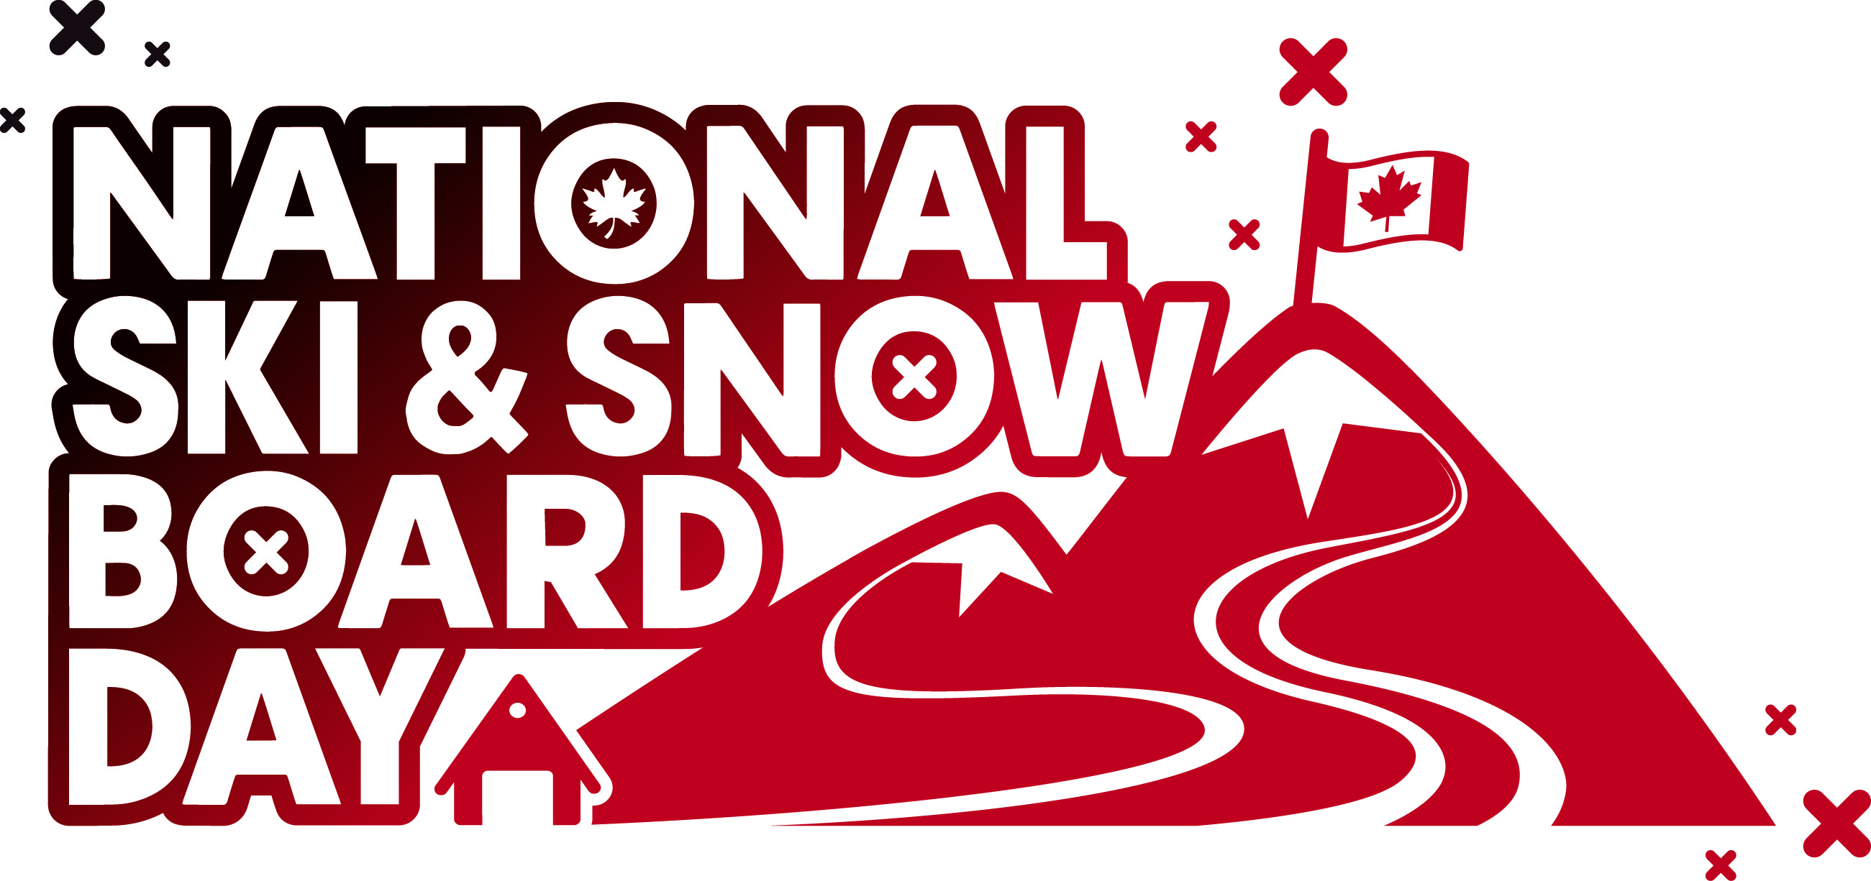

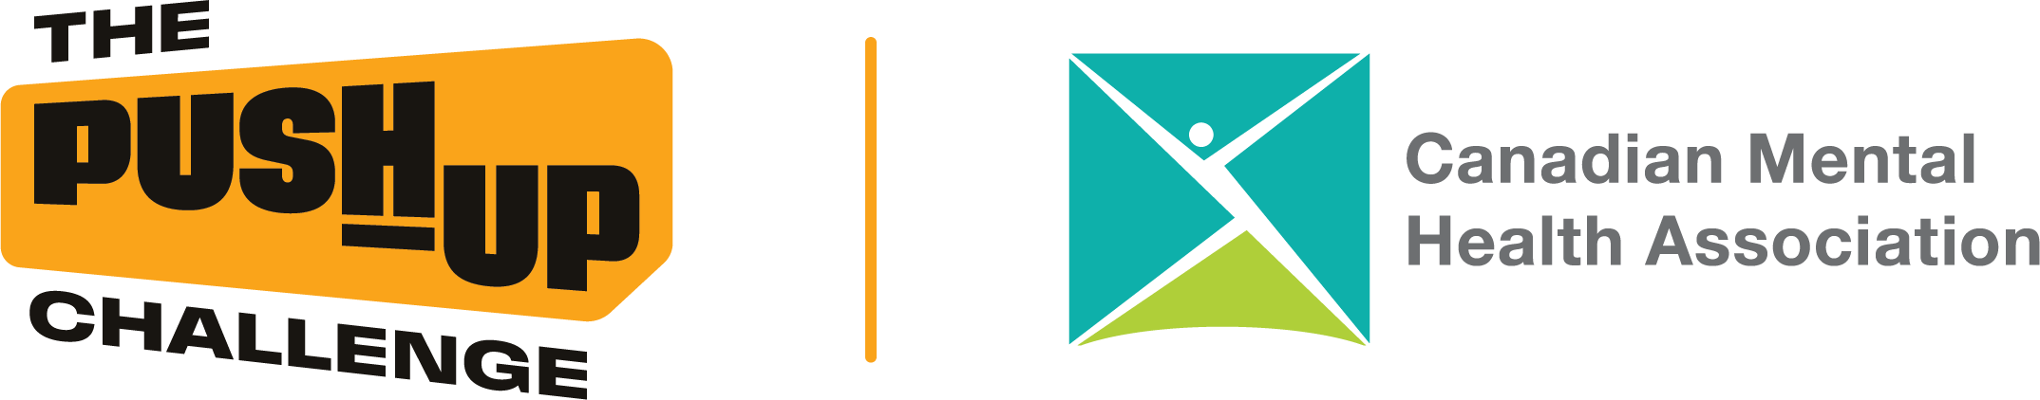

National Ski & Snowboard Day 2026

Winter Moves You
Friday, February 20, 2026
In partnership with Canadian Mental Health Association (CMHA)
What is National Ski and Snowboard Day?
National Ski & Snowboard Day (NSSD) celebrates skiing (alpine & Nordic) and snowboarding across Canada. In 2026, the Winter Moves You theme highlights how staying active in winter - even in small ways - supports mental well-being. This is a low-barrier, awareness-first initiative. People can take part however they choose. Donations to CMHA are optional.

Who Can Take Part
- Ski areas & associations
- Staff teams (ski school, patrol, ops, admin)
- Ski clubs & teams
- Athletes (alpine, freestyle, snowboard, Nordic)
- Guests & local community members

How to Participate (choose what works for you and your ski area)
Participation can be big or small - all movement counts. Anytime leading up to or on Feb 20, share images and videos from the options below on social and use some of our hashtags (found in below social media ideas). We’ll encourage resharing to help keep the momentum going:
- Group Photo
Take a simple ‘Winter Moves You’ group photo at the base area or another safe spot.
- Winter Movement Moments
Invite guests and staff to share how they move in winter - skiing, snowboarding, walking, snowshoeing, skating, playing outside.
- Group Push-Up Moment
Gather a small group (even 5–10 people) and do a short push-up set together (modified options welcome).
- Winter Movement Flash Mob
A quick, visible movement moment in the base area (push-ups, squats, warm-up movements) on Feb 20.
- Awareness-Only Participation
Post a winter movement photo or video, tag a friend.
- Optional Donations
Participants may donate directly to CMHA if they choose. Donation is not required to participate.

Landing Page & Assets
Here is a landing page you can add to any communication (website, email, newsletters, or social posts) to provide background on National Ski & Snowboard Day and the Winter Moves You campaign:
https://www.skicanada.org/national-ski-snowboard-day/

If you would like logos in any other formats or sizes, please let us know.

As you’ll see in the social media examples below, this is the official link to direct people to if they wish to take part in the optional Push-Up Challenge: https://www.thepushupchallenge.ca/
*Participation in the Push-Up Challenge is optional. All winter movement and awareness posts are encouraged.

Suggested Prompt for Guests, Staff & Athletes
Use this prompt across posts, videos, stories, and captions:
‘What moves you in winter?’
Examples:
- ‘Winter moves me because ___.’
- ‘In winter, movement helps me feel ___.’
- ‘This winter, I’m moving by ___.’
Athletes within your network are encouraged to share short videos or photos answering this prompt in their own words, and to contribute content during the kickoff and lead-up to Feb 20.

Key Dates & Timeline

Campaign Window, February 1–20, 2026
Optional Key Moments to share across your social channels:
- Jan 19-30: Save-the-date awareness and Call to Participation
- Feb 2-6: Campaign Kickoff
- Feb 9-13: Community + Athlete Focus
- Feb 16-19: Flash Mob + Group Moment Reminder
- Feb 20: National Ski & Snowboard Day (main activation day)
- Following Feb 20: Wrap-Up

Simple Social Media Calendar (optional copy and paste ideas for your social media)

Hashtags:
Please include #WinterMovesYou, #NSSD2026, #CMHA(plus the name of your local branch), #thepushupchallenge, your ski area or regional hashtag, and #GoSkiingGoSnowboarding

Jan 19-30 - Save-the-date awareness and Call to Participation

National Ski & Snowboard Day is February 20.

This year’s theme, Winter Moves You, celebrates how winter movement - from skiing and snowboarding to simply getting outside - supports mental wellness.

In the lead-up to Feb 20, and in partnership with the Canadian Mental Health Association, we’re inviting Canadians to reflect on how winter moves them and to share photos and short videos showing what winter movement means to them.

Stay tuned for prompts, updates, and contests hosted by GoSkiingGoSnowboarding in the weeks ahead.

How we’re celebrating: (add how your ski area plans to mark National Ski & Snowboard Day)
#WinterMovesYou, #NSSD2026, #CMHA(plus the name of your local branch), #thepushupchallenge, your ski area or regional hashtag, and #GoSkiingGoSnowboarding

Feb 2-6 - Campaign Kickoff

Winter Moves You starts today!

To support winter wellness, and in collaboration with the Canadian Mental Health Association, we’re encouraging participants to incorporate push-ups as part of their warm-up before heading out on the slopes - a simple way to keep moving and support mental health.

Show us how you move in winter - on snow or off. Tag a friend and join us in the lead-up to Feb 20.

Learn more about the CMHA Push-Up Challenge here: https://www.thepushupchallenge.ca/
#WinterMovesYou, #NSSD2026, #CMHA(plus the name of your local branch), #thepushupchallenge, your ski area or regional hashtag, and #GoSkiingGoSnowboarding

Feb 9-13 - Community + Athlete Focus

What moves you in Winter?

Anyone incorporate push-ups as part of their warm-up before hitting the slopes? Share your winter movement moment and how it supports your mental wellness.

Tag a friend to join.
#WinterMovesYou, #NSSD2026, #CMHA(plus the name of your local branch), #thepushupchallenge, your ski area or regional hashtag, and #GoSkiingGoSnowboarding

Feb 16–19 - Flash Mob + Group Moment Reminder

It’s time to gather your crew!

On Feb 20, Canadians from coast to coast will come together for National Ski & Snowboard Day with a simple winter movement moment - on snow or off. Ski areas, athletes, families, friends, and communities are all welcome.

Whether it’s a group warm-up, a push-up moment, or another way winter moves you, plan your flash mob or group moment now and be part of a national movement celebrating winter, movement, and mental wellness.

Share your plans, tag your group, and get ready to move together on Feb 20.

#WinterMovesYou, #NSSD2026, #CMHA(plus the name of your local branch), #thepushupchallenge, your ski area or regional hashtag, and #GoSkiingGoSnowboarding

Feb 20 (day-of) - National Ski & Snowboard Day

It’s National Ski & Snowboard Day!

From coast to coast, Canadians are moving together and supporting mental wellness through winter movement.
Tag a friend and share how you’re moving today.

#WinterMovesYou, #NSSD2026, #CMHA(plus the name of your local branch), #thepushupchallenge, your ski area or regional hashtag, and #GoSkiingGoSnowboarding

Wrap-up Post for sharing after Feb 20:

That’s a wrap on National Ski & Snowboard Day 2026!

From coast to coast, Canadians showed us how Winter Moves You - supporting mental wellness through movement, connection, and time outdoors.

Thank you to the athletes, ski areas, partners, and community members who shared their stories and took part. Every post, push-up, and winter moment mattered.

Let’s keep moving, staying connected, and supporting one another all winter long.
#WinterMovesYou, #NSSD2026, #CMHA(plus the name of your local branch), #thepushupchallenge, your ski area or regional hashtag, and #GoSkiingGoSnowboarding

Key Messages (with supporting points)

Winter movement supports mental wellness
- Even small moments of movement can help people feel better
- Getting outside in winter supports both mental and physical health
- Movement doesn’t need to be intense to matter

Everyone can take part
- All ages, abilities, and activity levels are welcome
- Skiing, snowboarding, walking, stretching, playing - it all counts
- Participation matters more than performance

Winter Moves You is about connection
- Moving together builds community
- Sharing movement moments helps reduce isolation
- Tagging a friend invites others to join in

Ski areas are community hubs in winter
- Ski areas bring people together during the winter months
- They play a key role in supporting active, healthy communities
- Even small on-site moments create big impact

Support for mental health is accessible
- CMHA provides trusted mental health resources nationwide https://cmha.ca/
- The Push-Up Challenge offers a simple way to connect movement and awareness
- Donations are optional - awareness and participation come first

What CSC Will Do Nationally

- Issue national and regional media releases incorporating quotes from various Industry and CMHA branches across the country
- Coordinate national messaging with CMHA
- Amplify ski area, association, and athlete content
- Encourage engagement from government and community leaders

What We Need From Ski Areas & Associations

- Confirm participation
Email: leslie@skicanada.org
- Plan one simple activity or way to celebrate on February 20 (group photo, push-up moment, or movement post)
- Share your best photo/video with CSC for national amplification

